COMSATS University Islamabad
Lahore Campus, Department of Computer Science
CSC241 Theory Assignment 1
Object Oriented Analysis of a Smart Campus Allocation System
Course | CSC241 Object Oriented Programming (Java) | Section | BCS
Assessment | Theory Assignment 1 | Mapped CLO | CLO1
Student | Zameeha Fatima | Registration No. | SP26-BCS-057
Instructor | Dr Muhammad Shahid Bhatti | Due date | 26 September 2026
Student-specific condition | Emergency continuity (last digit of registration number = 7)
How I approached this assignment
This report analyses the Smart Campus Learning Space Allocation System described in the assignment brief. Because my registration number ends in 7, my required extra condition is “Emergency continuity”: a building closure may trigger cancellation, relocation, and notifications across many reservations at once. I have tried to weave this condition into the class model, the invariants, and the edge-case handling wherever it is relevant, rather than treating it as a separate add-on.
Facts taken directly from the assignment brief are written as facts. Anywhere I had to fill a gap the brief left open (for example, what “fair access” means, or how a tie between two simultaneous requests is broken), I have marked it clearly as my own assumption.

Task 1: Stakeholder and Requirement Analysis

1.1 Stakeholders and their needs
Stakeholder | One key need
Students | Fast, fair access to book a space for study, group work, or a class, without feeling that faculty always take priority.
Faculty members | Reliable priority for scheduled teaching and urgent academic work, so a booked classroom cannot be quietly taken away.
Administrators | Clear utilization data (which rooms are busy, which are idle) so space and budget decisions can be made.
Security staff | An accurate, traceable record of who accessed which space and when, for safety and investigations.
Maintenance staff | The power to block an unsafe room immediately, without waiting on anyone else's approval.
Disability support staff / users needing accessible rooms | A guarantee that accessible rooms stay reachable for the people who need them, without their disability status being shown to other users.
Table 1.1: Stakeholders and one representative need each.

1.2 Three genuine requirement conflicts
Conflict 1: Fair access for students versus teaching priority for faculty. The brief asks for fair access for students while also giving faculty priority for scheduled teaching and urgent academic activity. These two goals clash whenever a student and a faculty member want the same slot.
Decision needed: the system must define exactly when priority is allowed to override an existing booking, and by how much notice. My assumption: a faculty request tied to a scheduled class or a flagged “urgent academic” reason may override a student's non-class booking only if made at least two hours before the slot starts, and the displaced student must be notified immediately and offered an alternative room where one exists.
Conflict 2: High room utilization for administration versus immediate safety blocking for maintenance. Administrators want rooms booked as often as possible, but maintenance staff must be able to take a room out of service the moment it becomes unsafe, even if that room was fully booked.
Decision needed: whether a maintenance block can be delayed or questioned by anyone. My assumption: a maintenance block always takes effect immediately and cannot be reversed by a utilization rule. Blocked hours are recorded separately from idle hours, so a room that was blocked for safety is not counted as “wasted” in the utilization report.
Conflict 3: Traceable access records for security versus personal privacy for users. Security staff need to know who used a space and when, but users expect their personal details and the purpose of their booking to stay private.
Decision needed: who is allowed to see the identity and purpose behind a reservation, and who can only see whether a room is busy. My assumption, which is also the required “Privacy first” style condition for other students, is applied here too in spirit: ordinary users only ever see whether a space is free or occupied. Only security staff and administrators can open the full access log that links a booking to a person's identity.

1.3 Facts versus assumptions
Facts stated in the brief | Assumptions I have added
Six stakeholder groups are named: students, faculty, administrators, security staff, maintenance staff, disability support staff. | A two-hour cutoff before a faculty override is allowed to displace a student booking.
Four request types exist (individual activity, group meeting, class, academic event), each with different capacity, equipment, and approval rules. | Maintenance blocks are absolute, immediate, and cannot be reversed by anyone else in the system.
A person may hold more than one role at the same time, and roles/permissions may change during the semester. | Access logs (who, when, which room) are only visible to security staff and administrators, never to ordinary users.
Emergency events may cancel or relocate confirmed reservations; the system must keep enough information for an audit and must notify affected users. | Simultaneous identical requests are resolved first by the priority rule from Conflict 1, then by whichever valid request was received first.
“Fair access”, limits on recurring reservations, and the handling of simultaneous requests are explicitly left undecided by the university. | A recurring booking series is capped at one confirmed slot per week per person until an administrator raises the limit (a placeholder rule, since the brief leaves this open).
Table 1.2: Separating brief facts from the assumptions used later in this report.

Task 2: Object Oriented Conceptual Model

2.1 Proposed classes
I settled on ten classes. Each one covers a single, clear responsibility, which is what Task 2 and the CLO1 rubric ask for (“suitable classes and responsibilities”).
Class | Responsibility | Key attributes / operations
Person | Represents one real human using the system, independent of whatever role(s) they currently hold. | name, personId, contactInfo · updateContact()
RoleAssignment | Represents one role held by a person for a period of time, and the permissions that come with it. | roleType, startDate, endDate, permissions · isActiveOn(date), grantPermission()
Reservation | Represents one booking request from creation to its final outcome; owns its own status and lifecycle. | reservationId, timeSlot, status, purpose (hidden) · confirm(), cancel(), relocate()
Space | Represents one physical bookable room and its current condition. | spaceId, capacity, status, accessibleFlag · block(), isAvailable()
ActivityType | Represents one kind of request (individual, group, class, event) and the capacity/equipment rule that applies to it. | typeName, capacityRule, requiresApproval · validate(request)
ApprovalPolicy | Decides whether a specific request should be approved, using the rule set that belongs to its activity type. | ruleSet, priorityOrder · evaluate(request)
Equipment | Represents one item of movable, shared equipment and how much of it is currently free. | equipmentId, isMovable, quantityAvailable · allocate(), release()
AccessLog | Records one traceable entry/exit or system event for audit purposes. | logId, timestamp, entryType · record()
NotificationService | Sends a message to an affected person when something about their reservation changes. | channel, template · notify(person, event)
EmergencyEvent | Represents one building closure or similar emergency and coordinates the cancellations/relocations it causes. | eventId, reason, affectedSpaces · cancelAll(), relocateAll()
Table 2.1: The ten proposed classes, their responsibility, and their main members.

2.2 UML class diagram
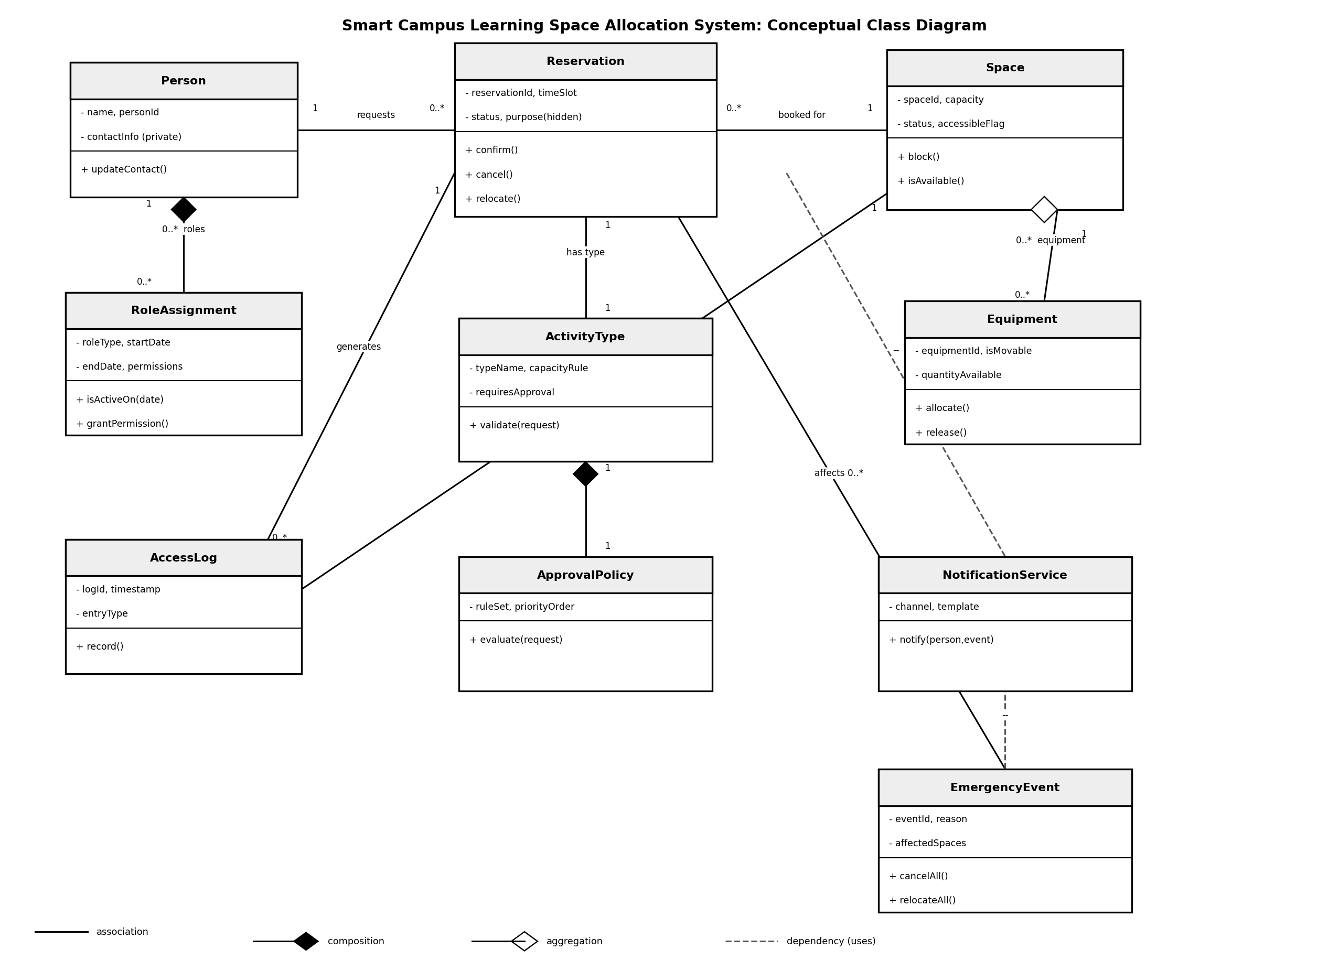
Figure 2.1: Conceptual class diagram for the Smart Campus Learning Space Allocation System.
Composition is used between Person and RoleAssignment, and between ActivityType and ApprovalPolicy, because a role or a policy has no meaning once its owner is deleted. If a Person record is removed, its RoleAssignments should be removed too. Aggregation is used between Space and Equipment, because equipment can exist and be reassigned even if a particular room is temporarily closed, so the two can be separated. Dependencies (dashed arrows) show a class that simply uses another to do a job. Reservation and EmergencyEvent both use NotificationService to send a message, but neither of them stores a permanent link to it.

2.3 How responsibility is separated
No single class is allowed to know everything. Reservation only manages the state of one booking (requested, confirmed, cancelled, and so on); it does not decide whether a request is allowed. That decision belongs to ActivityType and ApprovalPolicy, which hold the capacity and approval rules for each request type. Space only tracks whether a room is available or blocked; it does not decide who gets to book it. Equipment only tracks its own availability, separately from the room it happens to sit in. AccessLog only records events, and NotificationService only sends messages. Neither one makes decisions about the reservation itself. EmergencyEvent coordinates a batch of changes during a closure, but it still goes through each Reservation's own methods rather than editing reservation data directly. Splitting the work this way means a change to, say, the approval rules for group meetings only touches ApprovalPolicy and ActivityType, not the whole system.

Task 3: Abstraction, Encapsulation and Invariants

3.1 Reservation
What it abstracts: the everyday idea of “someone holding a room for a stated time, for a stated reason.” It hides all the checking, approval, and messaging machinery behind three simple actions: confirm(), cancel(), and relocate().
What is hidden, and how it may change: the exact purpose/description of a booking is hidden from ordinary users to respect privacy, and the status field can never be edited directly. It only ever changes through confirm(), cancel(), or relocate(), so an outside class cannot push the reservation into an invalid state by accident.

3.2 Space
What it abstracts: a physical, bookable place with a capacity and a current condition (open or blocked). It hides how the block/available check is actually carried out.
What is hidden, and how it may change: whether a room is currently blocked, and why, is hidden and can only change through block(). Nothing outside Space is allowed to flip its status directly. accessibleFlag is exposed only as a simple yes/no marker, never linked to any user's personal or disability information.

3.3 RoleAssignment
What it abstracts: the fact that what a person is allowed to do can change over time without changing who that person is. It separates “identity” (kept in Person) from “current permissions” (kept here).
What is hidden, and how it may change: the permission list is hidden and can only change through grantPermission() (and an equivalent revoke operation), and the active/inactive state is only ever read through isActiveOn(date), never by comparing dates from outside the class.

3.4 Invariants that must always remain true
- A confirmed reservation's time slot can never overlap with another confirmed reservation for the same space.
- A space whose status is “blocked” can never hold a confirmed reservation until it is unblocked.
- A RoleAssignment's endDate, if it is set, can never be earlier than its startDate.
- A reservation that requires an accessible room can only be confirmed against a Space whose accessibleFlag is true.
- Every reservation that an EmergencyEvent cancels or relocates must leave behind a matching AccessLog entry, so the change can be audited later.
Encapsulation is what makes these invariants enforceable. Because Reservation, Space, and RoleAssignment only allow changes through their own methods, each rule can be checked in exactly one place, the method itself, instead of trusting every other class in the system to remember and re-check the rule correctly. This is what stops the model from ever reaching an invalid state, such as a confirmed booking sitting inside a blocked room.

Task 4: Alternative Designs and Decision

4.1 Two ways to model users with changing roles
Option A models a role by making it a subclass of Person (for example Student extends Person, Faculty extends Person). Option B, which is the one I actually used in Task 2, keeps Person as a single class and attaches any number of RoleAssignment objects to it through composition.
Criterion | Option A: Inheritance (Student, Faculty, and so on as subclasses of Person) | Option B: Composition using role objects (Person holds RoleAssignment objects)
Handling multiple roles at once | Awkward. A person cannot literally be two subclasses at the same time, so a student who is also a teaching assistant needs extra workarounds such as interfaces or duplicate objects. | Natural. A person simply holds a list of RoleAssignment objects, so any combination of roles is possible without changing the class hierarchy.
Ease of changing roles mid-semester | Costly. Changing role means creating a new subclass instance and migrating the person's data across. | Cheap. Changing role just means adding or ending a RoleAssignment, and the Person object itself never has to change.
Coupling and duplicate behaviour | Booking-permission logic tends to get copied into several subclasses, or pushed into a deep, fragile hierarchy. | Role-specific rules live in one small, reusable RoleAssignment class shared by every person, so logic is written once.
Table 4.1: Comparing inheritance and composition on three criteria.

4.2 Decision
I chose Option B, composition using RoleAssignment objects. The brief states directly that “a person may hold more than one role, such as student and teaching assistant” and that “roles and permissions may change during the semester.” Both of these are exactly the situations that inheritance handles badly and composition handles well, so the requirement itself points to Option B rather than either being a stylistic preference.

Task 5: Behaviour and Edge Cases

5.1 Reservation life cycle (state transition table)
State | What it means | Can move to
Requested | The booking has just been submitted and has not been checked yet. | PendingApproval, or Cancelled if it fails a basic check (e.g. space does not exist).
PendingApproval | ApprovalPolicy is evaluating the request against the activity type's rules. | Confirmed (approved) or Cancelled (rejected).
Confirmed | The booking is active and is currently holding the space for its time slot. | Cancelled, Relocated, or Completed.
Relocated | The booking has been moved to a different space, usually because of a block or an emergency. | Confirmed (at the new space) or Cancelled if no alternative space is found.
Cancelled | The booking has ended without taking place. Kept in the system for audit purposes. | Final state.
Completed | The time slot has passed normally and the booking was used as planned. | Final state.
Table 5.1: States a Reservation can be in and the moves allowed between them.

5.2 The three required edge cases
Two simultaneous requests for the same space. The first valid request to reach Reservation locks the slot and moves to PendingApproval; the second is checked against the priority assumption from Task 1 (a qualifying faculty request may still override a plain student request if it arrives early enough) and is otherwise queued or rejected. The displaced requester is told through NotificationService. Enforcement: Reservation performs the actual lock/state change, using the rule supplied by ApprovalPolicy. Neither class does the other's job.
A maintenance block after confirmation. Space.block() runs immediately, exactly as the brief demands (“maintenance staff must be able to block unsafe rooms immediately”). Any Confirmed reservation attached to that space is moved by Reservation itself into Relocated (if another suitable space is free) or Cancelled (if not), and NotificationService informs the affected user. Enforcement: Space decides and acts on the block, and Reservation only reacts to it and changes its own state. Space never edits Reservation's data directly.
Emergency cancellation or relocation (my Emergency continuity condition). When a building closure is declared, EmergencyEvent.cancelAll() or relocateAll() runs across every Reservation tied to the closed spaces. Each Reservation still transitions itself through its own confirm()/cancel()/relocate() methods rather than being edited from outside, so the invariants from Task 3 stay protected even during a mass update. Every change produces an AccessLog entry for the audit trail (Invariant 5), and NotificationService messages every affected user once the batch is done. Enforcement: EmergencyEvent only coordinates and triggers the batch; the individual Reservation objects remain the ones that actually enforce their own rules.

Task 6: Independent Exploration

6.1 The Strategy pattern
The Strategy pattern is a way of pulling an algorithm that can vary out of the class that uses it, and putting each version behind a shared, interchangeable interface. Instead of writing a long if/else chain to pick between different rules, a class simply holds a reference to a “strategy” object and calls one method on it. The class using the strategy does not need to know which specific version it is running, only that every version answers the same call (Refactoring.guru, n.d.). The idea was first described formally as one of the classic reusable object-oriented design patterns, where it is presented as a way to let an algorithm vary independently of the clients that use it (Gamma et al., 1994).
In my model, this fits ApprovalPolicy exactly. Each ActivityType (individual, group meeting, class, or academic event) needs a different approval rule, but Reservation should not need to change every time a rule changes. By treating ApprovalPolicy as a strategy that ActivityType simply calls through evaluate(request), a new activity type, or a changed rule for an existing one, can be added without touching Reservation or ActivityType's own code at all.

References
Refactoring.guru. (n.d.). Strategy. Retrieved September 2026, from https://refactoring.guru/design-patterns/strategy
Gamma, E., Helm, R., Johnson, R., & Vlissides, J. (1994). Design patterns: Elements of reusable object-oriented software. Addison-Wesley.

Generative AI Use Disclosure
I used a generative AI tool (Claude, by Anthropic) while preparing this assignment. I used it to help organize my analysis, draft the class diagram layout, and check that I had covered every part of the brief. I reviewed, edited, and take full responsibility for every stakeholder, class, invariant, and design decision presented in this report.

